CFS3 Landclass file generation tutorial.
Version 1.0 – 25/07/2016 – odin_br
Revised By –
Requirements
- CFS3.1
- CFS3 Terrain SDK
- Any Photoshop version (6,7,CS,CS2..CS6)
- Martin´s CFS3 SDK tutorial on http://www.mwgfx.co.uk/cfs3/cfs3sdk.htm
Objective
This guide describe the TIFF file generation for use to create a cfs3 landclass LCF file.
Introduction
Nowadays, there are at least, 4 kinds of 32bit TIFF file format . The 32bit file format used for CFS3 landclass generation have: 8 bits/channel and RGBA color format (red, green, blue and alpha). The steps to create this TIFF file on photoshop and the LCF file generation is showing by the following description.
Description
Step1 – Painting theatre landclass
Read carefully the landclass section of Martin´s cfs3 sdk tutorial. Paint your landclasses like described.
TIP: You can use multiple layers for each landclass color. But after finish, you need to merge all layers into a single layer (flattened image). Note the dimensions of your file (Menu IMAGE – IMAGE SIZE..). IT MUST BE SQUARE.

Step 2 – Pixel Configuration
After the landclass painting with your colors in Photoshop, check the following parameters on IMAGE-MODE menu: RGB Color enabled and 8bits/channel enabled.

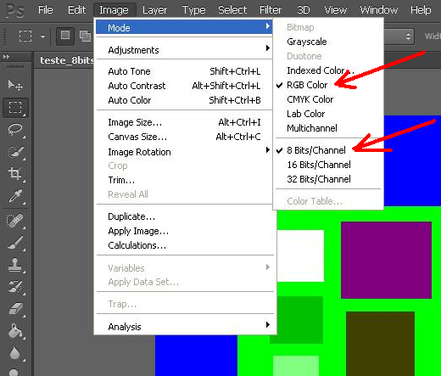

Step 3 – Adding an Alpha Channel
Select all image with menu Select – All
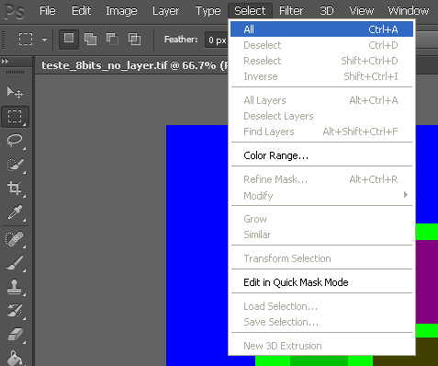

Save the selection with menu Select – Save Selection
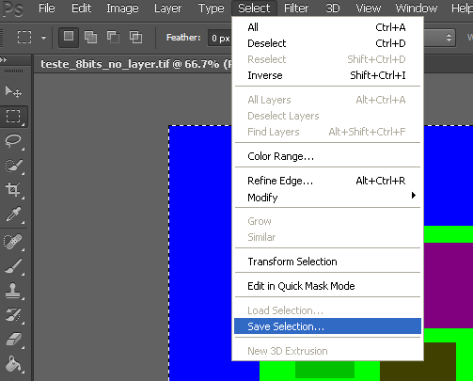

Only check to save the selection with new channel parameters – Click OK
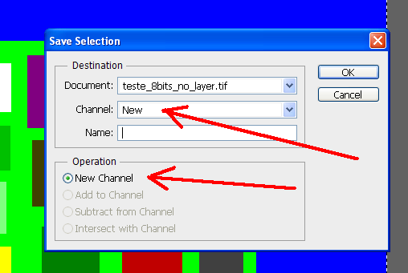

Check if the new Alpha channel was created
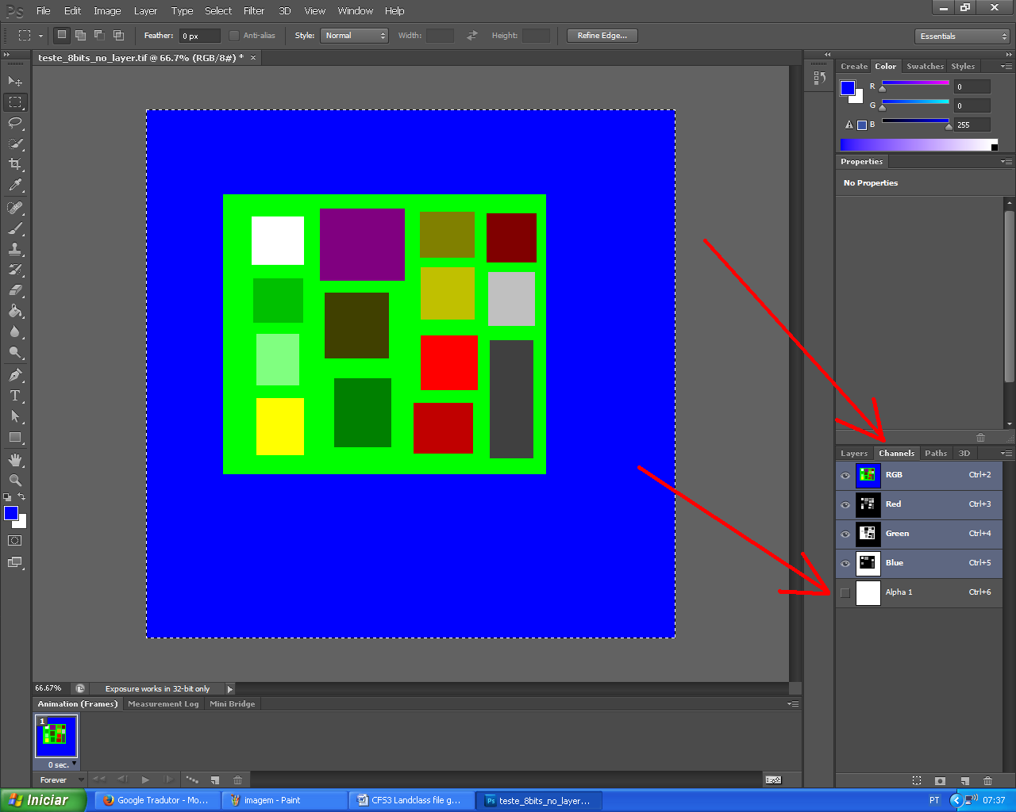
Step 4 – Saving the TIFF file. Check if the Alpha Channels is enabled. Press Save.
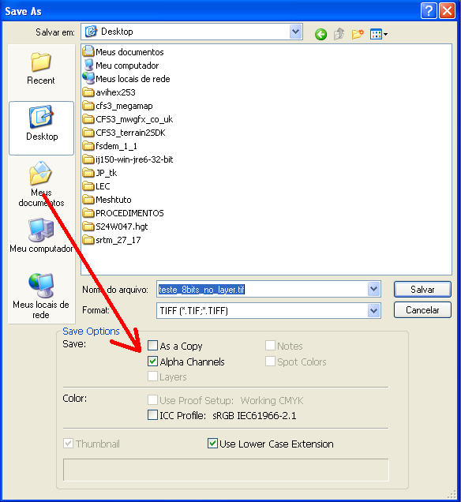

Use the 2nd save parameters for TIFF, like showed in next image. Press OK.
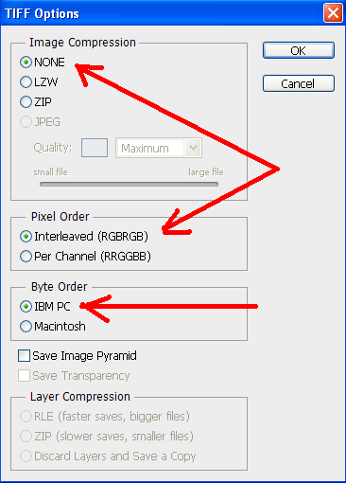

Step 5 – Converting the Tiff to LCF landclass file
Put your TIFF file on TOOLS subfolder of the CFS3 terrain SDK directory installation.
With the
TIFF file,
dimensions of your file and (In the case of this tut, test.tif, 1000pixels x 1000 pixels)
the text file of your landclass color (In the case of this tut, c2v.txt),
a copy of a landclass.xml from CFS3 instalation directory, subdir \terrains\terrdata.zip,
You’re ready to generate the LCF file with TIFF2LCF tool.
Open your command line window on CFS3 sdk \tools directory. (START-RUN-CMD-OK).

TIP: You can make a work new dir for these tasks. Just copy all DLLs and EXEs of a subdiretory TOOLS into a work directory. In my case, “c:\cfs3t”.
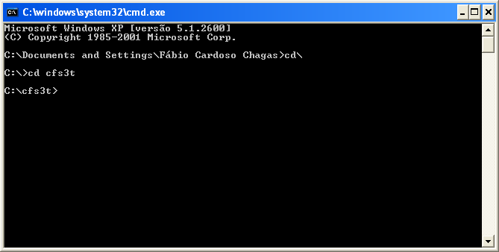

Execute the TIFF2LCF with correct parameters. In case of this tut:
tiff2lcf test8RGBA.tif c2v.txt 1024000 1024 landclasses.xml test.lcf
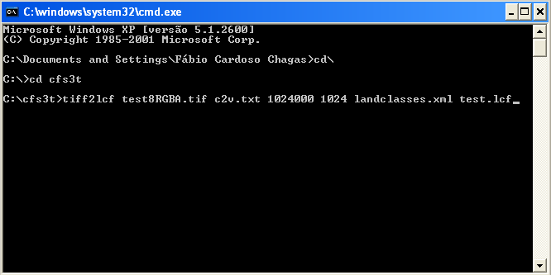
TIP: To copy and paste the line command, simply copy the text, and paste to command line windows using RIGHT MOUSE BUTTON- SUB menu window – PASTE. Do not use Keyboard CTRL-V, doesn´t work.
If you received the converting message, a LCF was generated. Check the file (In this case: TEST.LCF).
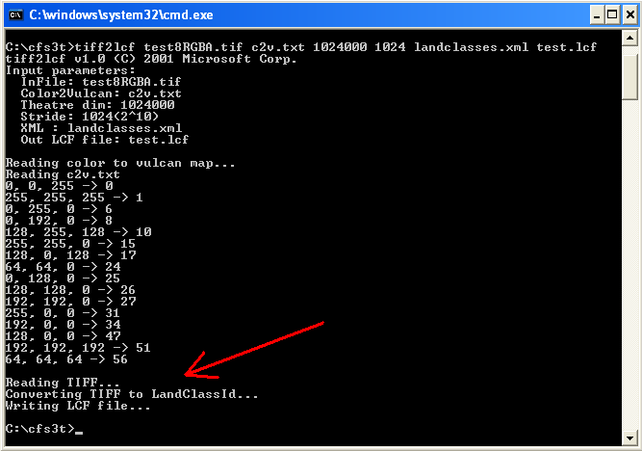

About tutorial files:
- c2v.txt – Martin´s example list of original cfs3 land colors.
- landclasses.xml – Original file from cfs3_install_dir\terrains\terrdata.zip
- test_8bits_no_layer.tif – Start Tiff file used for this tutorial without alpha channel. For the tutorial only with all colors described on c2v.txt. You can check RGB colors values using the EYEDROP photoshop tool.
- test8RGBA.tif – Finished file with alpha channel ready to LCF conversion
- command_line.txt – A text file with a command to you copy and paste to a command line window opened on tools directory.

Thanks:
To all SOH members.
Special Thanks:
- Martin Wright
- hairyspin
- gecko
- sdsbolt
- popsaka
- Daiwilletti
- Pat Pattle
- BorekS

Sugestions
If you have any suggestions, feel free to edit the tutorial. It is opened and free.
Also, if you are planning a new terrain theatre, release with it with an ORIGINAL TIFF file used for landclass. The CFS3 community can Edit it and improve it.

Best Regards,
Fábio Cardoso Chagas, aka Odin_br
odin_br@uol.com.br

